Contents
1 Introduction 3
1.1 Purpose and Scope 3
2 Design Overview 3
3 Detailed Design 5
3.1 JDBC driver for DBMS 5
3.1.1 Overview 5
3.2 StreamStore component implementation 7
3.2.1 Store 7
3.2.2 Write mode 8
3.2.3 Read mode 8
3.2.4 Example 8
3.2.5 Native serialisation streams 9
4 JDBC Driver configuration options 10
5 Missing features 10
6 Design Considerations 11
6.1 Localisation issues 11
6.1.1 Platform independent DLL/DSO loading 11
6.1.2 Storing current locale data without Kernel cooperation 11
6.2 Hardware/Platform assumptions 11
6.3 Compatibility considerations (Binary, Source, Data) 12
6.4 Modularity 12
7 Further Information 13
7.1 References 13
7.2 Open Issues 13
7.3 Glossary 13
Appendix A - DBMS SQL additions 14
A.1 AUTOINCREMENT 14
A.1.1 Example 14
A.2 Text index collation 14
A.2.1 Example 14

Introduction

Purpose and Scope
This document provides a design description of the DBMS JDBC driver component developed as part of PREQ2104 and PREQ2145. The target audience for this document are Symbian engineers in Release and Integration Tools (RIT), Persistent Data Services (PDS), Technical consultants and Lincesees.

Design Overview
DBMS is a database management system present in Symbian OS from its earliest revisions. Recently, Symbian has expended considerable effort to replace DBMS as the primary structured data storage via efforts such as Symbian SQL and Central Repository. However, a large number of applications still rely on DBMS.
One key challenge of using DBMS is the lack of tools. This fact has prompted multiple Symbian teams and licensees to develop tools for each DBMS application. In all cases the tools operate only on the emulator.
Often, the product creation efforts require some data to be pre-loaded in databases used by applications. This data can often be locale or operator specific meaning that the emulator-based tools were mandatory as far down the delivery path as operators. In some cases, databases were populated on first boot which was adversely affecting first-time user experience by slowing down boot process.
As part of wider variant creation streamlining effort, a set of DBMS creation tools has been proposed. The main requirement is emulator independent database creation. However, it has become apparent that building DBMS on TOOLS2 platform could yield significantly more functionality with little additional effort. In particular, a command line tool can be developed that would be able to load and modify existing databases, e.g. copied from a device. Such tools are invaluable to engineers at all delivery chain levels – to operators, licensees, Symbian’s technical consulting, Symbian development teams that use DBMS and the Persistent Data Services (PDS) team itself.
Further deliverable could be the DBMS port itself. For example, considering that there are existing tools written against the DBMS API, it is conceivable that such tools may be re-built against the ported DBMS. Therefore, DBMS along with Store and ported essential Symbian APIs can be delivered as a windows and linux native static libraries. Further still, tools that use basic APIs such as descriptors may also benefit from this.
Noting that Release and Integration Tools (RIT) team has already developed a database creation tool for Symbian SQL, the main deliverable for PREQ2104 is integration of DBMS into the existing database creation tool (SQLTool). Since the SQLTool is written in Java, integration requires additional effort of providing a JDBC driver for DBMS.
SDB interface to databases is exclusively via SQL. This is good – it allows the end user of SDB to specify all database operation in a plain-text SQL script. However, DBMS databases are usually accessed via API, with SQL support being quite limited and often insufficient. During PREQ2104 development we have identified several deficiencies in DBMS implementation of SQL that would seriously limit the number of use cases that can be implemented simply via SQL. This has been handled by adding support for specific statements and data types to DBMS’ SQL parser component. In essence, the required database functionality is already there – but could only be used via the API. We have simply added support for using it via SQL as needed by SDB. These changes are detailed in Appendix A -.
The Symbian database creation tool (SDB) architectural diagram is presented in Figure 1. The components outlined in the diagram are discussed in detail in following sections.
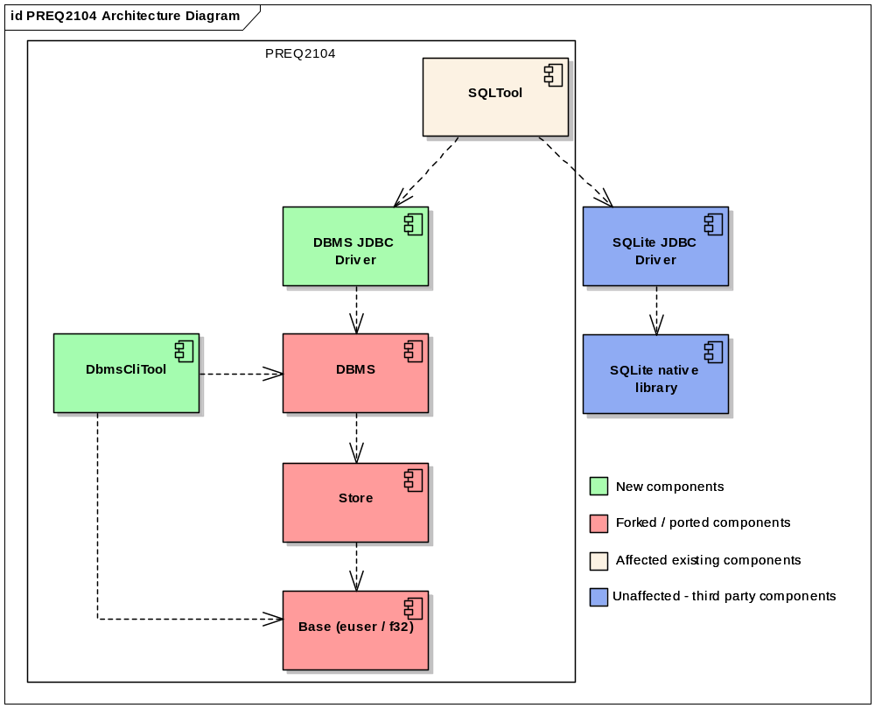
Figure 1 PREQ2104 Architecture diagram

As part of PREQ2104, PREQ2111 and PREQ2145, SDB has been expanded to offer additional functionality. Hence, SDB 2.0 architecture has somewhat changed and now requires a number of ported libraries. The native dependencies, including the JDBC driver are shown in the diagram below.

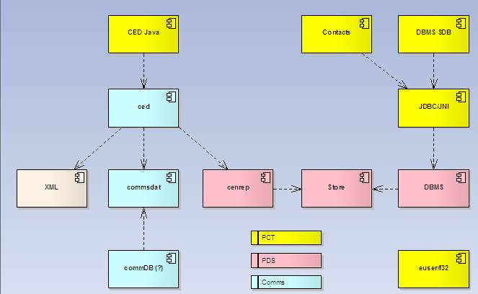
Figure 2 SDB 2.0 Native library dependencies

Detailed Design

JDBC driver for DBMS

Overview
A considerable work unit in PREQ2104 is implementation of a JDBC driver for DBMS.
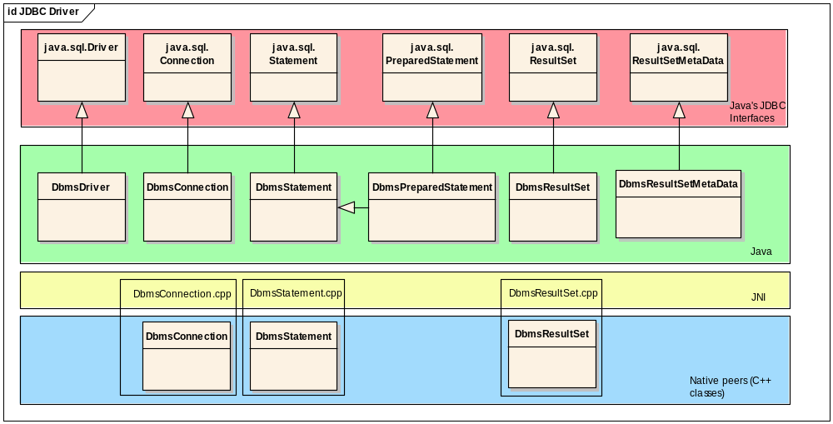
Figure 3 Java, JNI and native peer stack of the JDBC Driver
We have implemented a type-2 JDBC driver – essentially implementing JDBC interfaces on the one side and using the ported native core and DBMS APIs. These two layers then interface via Java Native Interface (JNI).
The Java layer provides implementations of the JDBC interfaces. Since database operations are implemented using the native libraries the code in Java layer has a number of native methods.
When using JNI, java code is compiled twice:
- Normal javac compilation
- The native include file generation via javah
The first step produces java classes as normal. Second step produces C header files with prototypes of C functions that we must provide to implement methods declared as native in the java code. For example consider following java declaration in com.symbian.dbms.jdbc.DbmsConnection:
private native void _close(int peerHandle);
After compiling with javah we get an include file called com_symbian_dbms_jdbc_DbmsConnection.h, and containing (among others):
/*
* Class: com_symbian_dbms_jdbc_DbmsConnection
* Method: _close
* Signature: (I)V
*/
JNIEXPORT void JNICALL Java_com_symbian_dbms_jdbc_DbmsConnection__1close
(JNIEnv *, jobject, jint);

These functions are implemented is in the “JNI layer” of our driver. When a corresponding java object is created, the JNI layer creates the native peer object instance. The pointer to the peer object is returned to Java allowing further JNI calls to retrieve and use the correct peer instance.
Existance of peers is not necessary, but provides an excellent pattern for managing native resources and especially their lifecycle. For clarity, we have maintained consistency with this pattern even when it was not necessary to have a peer object.
In our case, the native peers are little more than Symbian object containers. For example, consider the DbmsConnection native class:
class DbmsConnection {

public:
RDbNamedDatabase iDatabase;
TBool iOpen;
public:
DbmsConnection();
~DbmsConnection();

TInt Open(const TDesC& aFileName);
void Close();
}

Essentially, this class allows us to manage the DBMS API object RDbNamedDatabase.
So our native close method implementation is as follows:
/*
* Class: com_symbian_dbms_jdbc_DbmsConnection
* Method: _close
* Signature: (I)V
*/
JNIEXPORT void JNICALL Java_com_symbian_dbms_jdbc_DbmsConnection__1close
(JNIEnv * aEnv, jobject aJavaObj, jint aPeer) {
DbmsConnection* connection = (DbmsConnection*) aPeer;
connection->Close();
delete connection;
gConnectionCount--;
if ( gConnectionCount == 0 && gCleanup != NULL ) {
delete gCleanup;
gCleanup = NULL;
}
}

First line unwraps the DbmsConnection native peer object from the integer value passed in from java. This is essentially a pointer we have returned to java at the time the object was created (see _create method). Then, we use the object. This particular implementation also does some local reference counting and cleanup not necessarily relevant to this discussion.

StreamStore component implementation
In PREQ2145, Contacts model stores much of the data in BLOB columns. The BLOB data is typically produced using CEmbeddedStore SymbianOS API objects. The StreamStore Java component has been added in order to support this functionality from Java.
Since this functionality nicely aligns with the JDBC driver – e.g. uses same libraries, same paradigms, same build procedure, provides similar functionality and is used by the same application (SDB), it has been decided that this component be included in the JDBC driver.
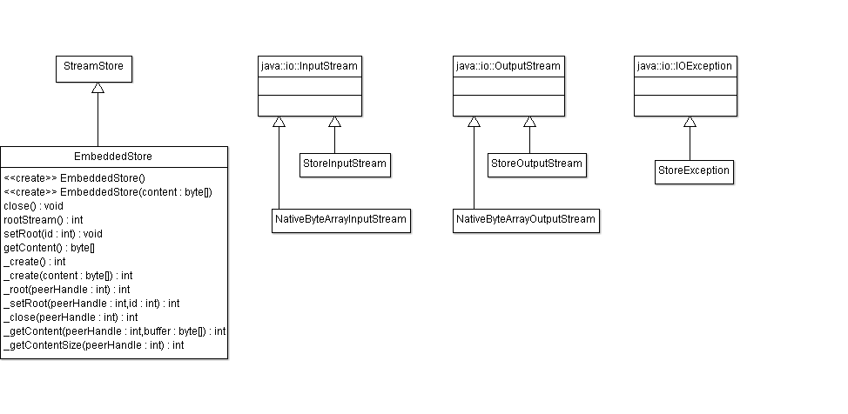
Figure 4 Store component Java classes
Note that only the Java implementation UML is presented above. The JNI and native peer layers are very similar to that in Figure 3 and have therefore been omitted.

Store
Store is a Symbian OS component that allows saving multiple streams in a single entity (e.g. a file or a memory buffer). There are several store implementations. More information on Symbian native store component can be found in developer library.
Contacts model makes heavy use of stores. In order to support this, we have developed a Java component that allows us to read and write the 'store' blob entirely in Java. The java store component is currently included in the JDBC driver. More info about JDBC driver and binaries can be found on the PREQ2104 page.
The class of most interest for PREQ2145 is EmbeddedStore. This class can be used in two modes:
- Write mode
- Read mode.
One embedded store instance cannot be used for reading and writing.
Once an embedded store is committed, it cannot be modified. The only way to modify a committed embedded store is to create a new one, copy the streams that should remain unchanged, then write the changed streams.

Write mode
In write mode, we use the store as follows:
- Create an empty store
- Create a stream using store.getOutputStream()
- Get the stream id stream.getStreamId()
- Set the store root stream using store.setRoot(streamId) - this is essential so that we can read the stream back
- You can now write to the stream or create any number of additional streams
- Once done writing, close the streams, then do store.commit()
- At this point you can retrieve the store content via store.getContent() which returns a byte array
- Finally, do store.close()
Few points to note:
- Store provides no API for listing streams. The API user must maintain stream IDs, apart from the root stream which, if set, can be retrieved using store.rootStream().
- Reminder: once committed, an embedded store cannot be modified.

Read mode
- Create a store from the byte array via new EmbeddedStore(bytes)
- Get the input stream via readStore.getInputStream(streamId)
- The root stream can be obtained via readStore.rootStream()
- Read from the stream, or open any other streams and read...
- When done, close the streams and also do store.close()

Example
Here is an example code for using store.
Note: This example ignores exception handling. You should declare store and streams outside try-catch and close in the finally block.
// create the store
EmbeddedStore store = new EmbeddedStore();

// get the stream
StoreOutputStream outstream = store.getOutputStream();

// get the streamid
int streamId = outstream.getStreamId();

// set the root stream
store.setRoot(streamId);

// use the stream, e.g
outstream.writeCardinality(0x12635);

// when done with the stream, close it
outstream.flush();
outstream.close();

// when done with the store, commit
store.commit();

// now we can get store content as byte array
byte[] bytes = store.getContent();

// done, close the store
store.close();

// Note - you can't use the same EmbeddedStore
// instance for reading and writing

EmbeddedStore readStore = new EmbeddedStore(bytes);

// open root strean
StoreInputStream in =
readStore.getInputStream(readStore.rootStream());

// read data
int card = in.readCardinality());

// done with the stream, close
in.close();

// done with the store, close
readStore.close();

Native serialisation streams
Two new classes for serialisation to symbian format from Java.
So far, to write a simple serialised stream we needed two EmbeddedStore instances and quite a bit of extra code.
This is simpler now because we have two classes: NativeByteArrayOutputStream and NativeByteArrayInputStream which behave very much the same as Java's ByteArrayInputStream and ByteArrayOutputStream.
The new classes internally use store and Symbian libs to offer writing as TCardinality, TDes8 or TDes16 etc.
This is super useful when we need to create a blob of serialised Symbian stuff, but the blob is not in store format.
// writing

NativeByteArrayOutputStream nbaos = null;
try{

nbaos = new NativeByteArrayOutputStream();
nbaos.writeInt32(10);

byte [] content = nbaos.toByteArray();
} finally {

// don't forget to close - we have native resources that will leak otherwise
if ( nbaos!=null) nbaos.close();
}
// reading

NativeByteArrayInputStream nbais = null;
try{

nbais = new NativeByteArrayInputStream(bytesFromBlob);
int read = nbais.readInt32();

} finally {
// don't forget to close - we have native resources that will leak otherwise
if ( nbais!=null) nbaos.close();
}

JDBC Driver configuration options
The driver provides a way to specify settings consistent with how this is normally done with JDBC drivers - via the connect URL. The connect URL BNF is as follows:

dbms-url ::= dbms:/<file-name>[?<param-name>=<value>[&<param-name>=<value>]*]

file-name ::= The file name on disk
param-name ::= Parameter name
value ::= Parameter value

Examples:

dbms:/test.db?volumeio.BlockSize=8192
dbms:/test.db?volumeio.BlockSize=8192&volumeio.ClusterSize=8192&localeDll=elocl.36

Following configurable parameters are supported:

Parameter name | Default value | Description
localeDll | null | Path to the locale DLL. If not specified uses default english locale.
dbms.secureId | None | The third UID stored in the database file header
volumeio.BlockSize | 4096 | See TVolumeIOParamInfo and RFs::VolumeIOParam in Developer library
volumeio.ClusterSize | 4096 | See TVolumeIOParamInfo and RFs::VolumeIOParam in Developer library

The block size and cluster size parameters are required because these are essentially used by DBMS to internally lay out data in the most efficient fashion for a particular medium. For example, if a flash chip has I/O characteristics such that 1Kb reads and writes are fastest, choosing appropriate block and cluster sizes can significantly improve database performance. The values must be specified by phone manufacturers.

Missing features
The DBMS JDBC driver offers limited JDBC access to DBMS databases. Most notable limitations are:
- Lack of DatabaseMetaData implementation
- Supports single threaded operation only
- Supports a single connection per database at a time
PREQ2104 and associated variant creation efforts did not present us with a use case for implementing these features.
The JDBC DatabaseMetaData could be implemented relatively easily – there are no major obstacles for this, but does require implementing some 100 functions.
The driver is primarily geared towards database creation – e.g. WRITE access to the database. The read access is provided via ResultSet and ResultSetMetaData implementations. While the read access is fairly complete it has been provided primarily for test purposes – e.g. to be able to test the tools using the driver without dropping to native code.

Design Considerations

Localisation issues
Symbian OS kernel is heavily involved in localisation. Localisation data defaults for English are hard-coded and built as part of symport component. However, localisation data for other locales is loaded from locale DLLs where the localisation data such as character set, collation code etc is maintained as global data by the kernel.
Since symport does not emulate Symbian OS kernel, we had to replicate this functionality. The current locale is kept in a global TExtendedLocale instance and appropriate functions in e32/euser/us_exec.cpp have been modified to support this.
One aspect of implementing localisation is the ability to load locale DLLs. Noting that or JDBC driver must support both Linux and Windows, the task is somewhat more complex.

Platform independent DLL/DSO loading
The first challenge is clearly platform-independent loading of locale DLLs. This is due to the fact that TOOLS2 builds in Linux environment and that our tool should ultimately support execution under linux.
This has been achieved by introducing additional class for dynamic DLL/DSO loading.
class DynamicLoader
{
public:
inline DynamicLoader() : iHandle(NULL) {};
TInt LoadL(const TDesC& aLocaleDllName, TLibraryFunction* aExportList);
void Free();
inline TBool IsLoaded() { return iHandle != NULL; };
private:
TAny* iHandle;
};

The implementation is conditionally compiled for Windows and Linux based on __LINUX__ macro.

Storing current locale data without Kernel cooperation
The second challenge is making provisions for storing the currently loaded locale data and integrating this new mechanism with existing code. This is achieved by maintaining global instances of DynamicLoader and TExtendedLocale. The global TExtendedLocale is populated by the loading code as necessary. In order to maintain behaviours related to default locale we have added the IsLoaded function to TExtendedLocale. This allows the locale initialisation code to select defaults when locale DLL has not been set.

Hardware/Platform assumptions
PREQ2104 output artefacts are targeted for TOOLS2 platform. TOOLS2 allows building native applications for Windows and Linux via GNU toolchain (MingW on windows).
In order to use JDBC driver, the target computer requires Java VM, however this is already a requirement for running SQLTool which is written in Java.

Compatibility considerations (Binary, Source, Data)
The ported e32, f32, store and DBMS code has fairly limited source compatibility with Symbian OS. However, this extends much further than similar previous efforts (e.g. PFSDump).

Modularity
PREQ2104 output is highly modular and each artefact may be used in isolation provided dependencies shown in Figure 1.

Further Information

References
No. | Document Reference | Version | Description
[R1]
[R2]

Open Issues

Glossary
Term | Definition
SDB | Symbian Database Creation utility developed by RIT
SQL | Structured Query Language
DBMS | Symbian’s legacy Database Management System
JDBC | Java Database Connectivity, a standard Java API for accessing databases
JNI | Java Native Interface – a set of C and C++ headers, libraries and tools for interfacing C/C++ libraries to Java
RIT | Release and Integration Tools team, previously known as PCT
PCT | Product Creation Tools, previous name for RIT

- DBMS SQL additions
SDB implementation
  - AUTOINCREMENT
DBMS supports COUNTER datatype which allows auto-increment on integer columns. However this is very limiting for several reasons:
- Standard SQL requires support for keyword AUTOINCREMENT
- COUNTER data type does not support any variation on integer such as UNSIGNED, SMALLINT or LONG.
We had very quickly come across UNSIGNED INTEGER AUTOINCREMENT column type in Symbian Log Engine and therefore concluded that proper support for AUTOINCREMENT be added to DBMS SQL.

    - Example
CREATE TABLE TEST ( id UNSIGNED INTEGER AUTOINCREMENT, name CHAR(80) )
  - Text index collation
The addition of collation specification for text index creation was required because such indices could not be created via SQL. Please see the use of TDbTextComparison in DBMS documentation for details.
The extension general form is as follows:
CREATE [UNIQUE] INDEX
<index-name> ON <table-name>(<column-list>)
[COLLATE NORMAL | FOLDED | COLLATED ]

    - Example
Let us assume we have a table as follows:
CREATE TABLE TEST (id INTEGER, name CHAR(30))

Creating text index with folding based on current locale can be achived via SQL as follows:
CREATE INDEX name_ind ON TEST(name) COLLATE FOLDED

